CHAPTER 7: ADVANCED OPTION STRATEGIES

END-OF-CHAPTER QUESTIONS AND PROBLEMS

1. (Bull Spreads) Buy one put with exercise price X₁ and sell one put with exercise price X₂. The profit equation is

Π = Max(0, X₁ – S_{T}) – P₁ – Max(0, X₂ – S_{T}) + P₂

If S_{T} < X₁ < X₂

Π = X₁ – S_{T} – P₁ – X₂ + S_{T} + P₂

= X₁ – X₂ – (P₁ – P₂)

Recall from Chapter 3 that the difference between exercise prices is less than the difference between premiums. Since X₁ < X₂ and P₁ < P₂, the above profit is negative.

If X₁ < S_{T} < X₂

Π = –P₁ – X₂ + S_{T} + P₂

This figure increases dollar for dollar with S_{T}. The breakeven is found by setting the profit to zero,

–P₁ – X₂ + S_{T}* + P₂ = 0

and solving for S_{T}*

S_{T}* = X₂ + (P₁ – P₂)

If X₁ < X₂ ≤ S_{T}

Π = –P₁ + P₂

Since P₂ > P₁, this figure is positive.

The minimum profit occurs in the first profit range, S_{T} < X₁ < X₂ and equals X₁ – X₂ – (P₁ – P₂). The maximum profit occurs in the third profit range, X₁ < X₂ < S_{T} and equals – P₁ + P₂.

2. (Straddles) A straddle is a strategy based on the expectation that the market will have high volatility. If, however, everyone else in the market believes that the market will have high volatility, then the prices of the call and put will reflect the higher volatility, which will result in breakeven points further away from the current stock price. A straddle is most likely to be successful when the investor believes that the market will be more volatile than everyone else in the market believes, and the investor’s expectations are more accurate.

3. (Box Spreads) In internal rate of return (IRR) problems; the return from the investment is compared to the opportunity cost of capital. The investment is acceptable if the IRR exceeds the opportunity cost. In the box spread problem, the investment pays X₂ – X₁. The initial outlay is C₁ – C₂ – P₁ + P₂. The IRR is the value of i that solves

(X₂ – X₁)(1 + i)^{-T} = C₁ – C₂ – P₁ + P₂

The opportunity cost is the risk-free rate, r. If i > r, then the box spread is acceptable. If i < r, then the box spread is overpriced and should be reversed.

4. (Bull Spreads) An alternative way to create a bull spread is with put options. With put options, the bull spread position is created by purchasing a low strike put option and selling a high strike put option
$Profit
Short X₂ Put
Long X₁ Put
Stock Price at Expiration
$0
Bull Spread With Puts

X₁ X₂
$Loss

5. (Bear Spreads) An alternative way to create a bear spread is with call options. With call options, the bear spread position is created by selling a low strike call option and buying a high strike call option.

Short X₁ Call
$Profit

Stock Price at Expiration
$0
Bear Spread With Calls

Long X₂ Call
X₁ X₂
$Loss

6. (Bear Spreads) Buy the October 170 at 6.
Sell the October 165 at 8.10.

Π = 100(Max(0, S_{T} – 170) – 6 –Max(0, S_{T} – 165) + 8.10)

Option Value at Expiration
S_{T} October 170 October 165 Profit
150 0 0 210
155 0 0 210
160 0 0 210
165 0 0 210
170 0 5 –290
175 5 10 –290
180 10 15 –290

Note: If you use OptionStrategyAnalyzer10e.xlsm to generate the graphs in this chapter, the horizontal axis will be labeled as the “Stock Price at Expiration.” Here it has been changed to “Stock Price at End of Holding Period.”

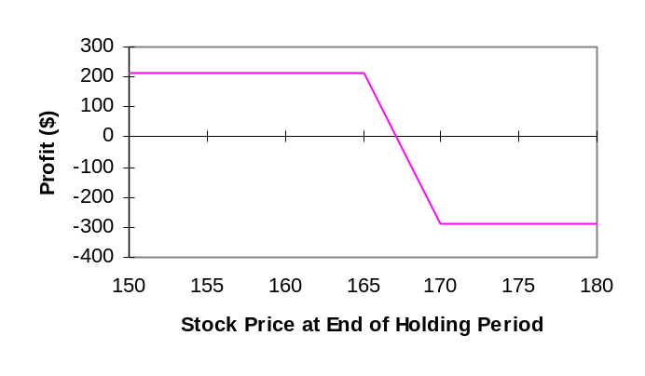

Breakeven stock price: X₁ + C₁ – C₂ = 165 + 8.10 – 6 = 167.10
Maximum profit: 210
Minimum profit: –290

A bear spread constructed with calls will be subject to the risk of early exercise. If the stock price rises sufficiently, then the short call can be exercised without the long call being in-the-money. Even if the long call is in-the-money and exercised, what will happen is that the loss on the upside will be incurred earlier. This will not happen, however, if there are no dividends on the stock during the life of the option.

7. (Bear Spreads) r_{c} = 0.0571 σ = 0.21

Time to expiration: T – t = 26/365 = 0.0712 (26 days between September 20 and October 16)

Plugging into the Black-Scholes-Merton model, we obtain the option values on September 20 for stock prices of 150, 155, … , 180.

Spread value on 9/20 = Value of 170 call on 9/20 – Value of 165 call on 9/20

Π = 100(Spread Value on 9/20 – 6.00 + 8.10)

Option Value on 9/20
S_{t} October 165 October 170 Profit
150 0.1914 0.0488 195.74
155 0.6862 0.2234 163.72
160 1.8642 0.7552 99.1
165 4.0260 1.9706 4.46
170 7.2362 4.1480 –98.82
175 11.2934 7.3443 –184.91
180 15.8809 11.3715 –240.94

Note: If you use OptionStrategyAnalyzer10e.xlsm to generate the graphs in this chapter, the horizontal axis will be labeled as the “Stock Price at Expiration.” Here it has been changed to “Stock Price at End of Holding Period.”

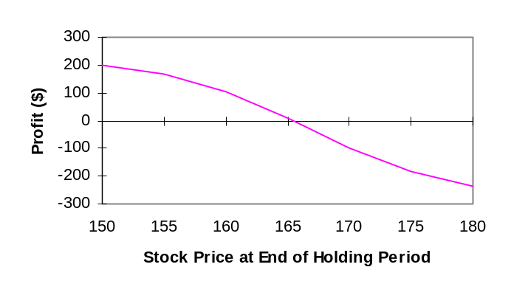

Approximate breakeven stock price: 166.

- (Bear Spreads) The October 160 put price is 4.5. We need to find an October call that has a price of 4.5. We use the Black-Scholes-Merton model with the inputs S₀ = 165.13, r_{c} = 0.0571, T = 102/365 = 0.2795,
σ = 0.21. Inserting various exercise prices into the model we find that at X = 174.83, the call price is about 4.50. Thus, we buy a put with an exercise price of 160 and sell a call with an exercise price of 174.83. The cost of the collar up front is the initial value of the stock, 165.13.

Time to expiration: T – t = 26/365 = 0.0712 (26 days between September 20 and October 16)

Plugging into the Black-Scholes-Merton model, we obtain the option values on September 20 for stock prices of 150, 155, … , 180.

Value of collar = 100 (Value of stock + Value of October 160 put – Value of October 174.83 call )
(Values of stock, put and call are on September 20.)

Π = 100(Value of collar – 165.13)

Option Value on 9/20
S_{t} October 160 Put October 174.83 Call Profit
150 9.9702 0.0109 –517.07
155 6.1092 0.0637 –408.45
160 3.2545 0.2686 –214.41
165 1.4795 0.8536 49.59
170 0.5679 2.1324 330.55
175 0.1834 4.3582 569.52
180 0.0499 7.5734 734.55

Note: If you use OptionStrategyAnalyzer10e.xlsm to generate the graphs in this chapter, the horizontal axis will be labeled as the “Stock Price at Expiration.” Here it has been changed to “Stock Price at End of Holding Period.”

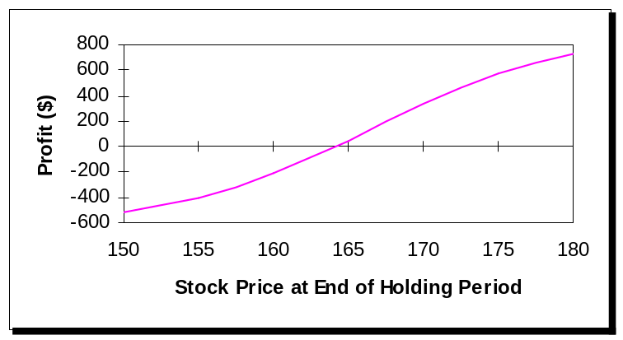

Maximum profit: ∞
Minimum profit: This clearly occurs when the stock is at zero. Then the call is at zero and the put goes to its maximum value, the present value of its exercise price of 160, which is 160e^{-0.0571(.0712)} = 159.3508. So you would have invested 165.13 and ended up with 159.3508 for a loss of 5.78, or $578 overall.
Approximate breakeven stock price: 164

9. (Butterfly Spreads) Sell October 160 at 11.10.
Buy two October 165's at 8.10 each.
Sell October 170 at 6.

Π = 100{2[Max(0, S_{T} – 165) – 8.10] – Max(0, S_{T} – 160) + 11.10 – Max(0, S_{T} – 170) + 6}

Option Value at Expiration
S_{T} October 160 October 165 October 170 Profit
150 0 0 0 90
155 0 0 0 90
160 0 0 0 90
165 5 0 0 –410
170 10 5 0 90
175 15 10 5 90
180 20 15 10 90

Note: If you use OptionStrategyAnalyzer10e.xlsm to generate the graphs in this chapter, the horizontal axis will be labeled as the “Stock Price at Expiration.” Here it has been changed to “Stock Price at End of Holding Period.”

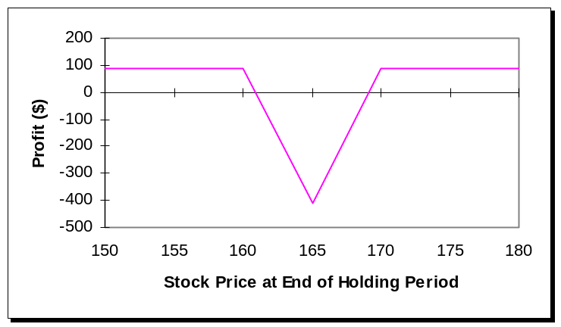

Breakevens:

X₁ + C₁ – 2C₂ + C₃ = 160 + 11.10 – 2(8.10) + 6 = 160.90
2X₂ – X₁ – C₁ + 2C₂ – C₃ = 2(165) – 160 – 11.10 + 2(8.10) – 6 = 169.10

Maximum profit: 90
Minimum profit: –410

10. (Calendar Spreads) Buy August 170 at 3.25.
Sell October 170 at 6.

August 170: T – t = 20/365 = 0.0548 r_{c} = 0.0535
October 170: T – t = 76/365 = 0.2082 r_{c} = 0.0571

(Based on 20 days between August 1 and August 21, and 76 days between August 1 and October 16)

Plugging into the Black-Scholes-Merton model, we obtain the option values on August 1 for stock prices at 150, 155, … , 180.

Spread value on 8/1 = Value of August 170 Call on 8/1 – Value of October 170 Call on 8/1

Π = 100(Spread Value on 8/1 – 3.25 + 6)

Option Value on 8/1
August 170 October 170 Profit
150 0.0164 0.8844 188.20
155 0.1083 1.7301 112.82
160 0.4793 3.0639 16.53
165 1.5084 4.9781 –71.97
170 3.5836 7.5118 –117.83
175 6.8145 10.6446 –108.01
180 10.9577 14.3064 –59.87

Note: If you use OptionStrategyAnalyzer10e.xlsm to generate the graphs in this chapter, the horizontal axis will be labeled as the “Stock Price at Expiration.” Here it has been changed to “Stock Price at End of Holding Period.”

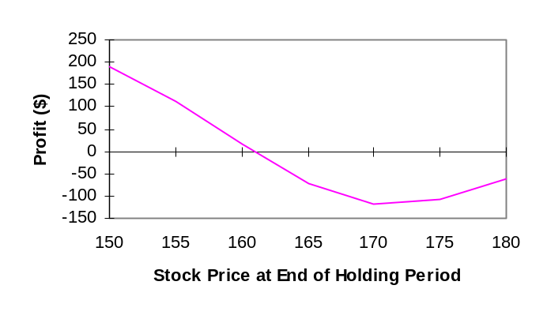

Maximum profit: 275 [if S_{T} = 0, profit = –100(3.25 – 6) = 275]
Minimum profit: –117.53
Approximate breakeven stock prices: 161 and 181

11. (Time Value Decay) Using the Black-Scholes-Merton model with r_{c} = 0.0571, σ = 0.21, S₀ = 165.13,
X = 165, and time to expiration as indicated below, we obtain the following values for the call on the dates indicated.

Time value = Option Value – Intrinsic Value (165.13 – 165 = 0.13)

Date Time to Expiration Time Value
7/15 0.2548 8.1228
7/31 0.2110 7.2876
8/15 0.1699 6.4410
8/31 0.1260 5.4416
9/15 0.0849 4.3673
9/30 0.0438 3.0368
10/16 0.0000 0.0000

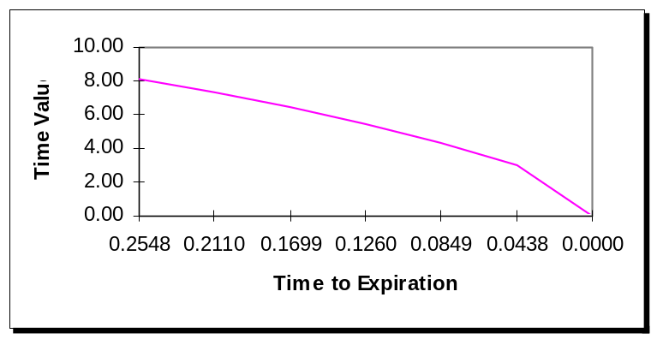

12. (Box Spreads) Using a spreadsheet for the Black-Scholes-Merton model:

August 160

S₀ = 165.13 X = 160 r_{c} = 0.0535 T = 46/365 = 0.1260

The delta [N(d₁)] is found to be 0.7092.

October 160

S₀ = 165.13 X = 160 r_{c} = 0.0571 T = 102/365 = 0.2795

The delta (N(d₁)) is found to be 0.6856.

If we buy the August 160 and write the October 160, the hedge ratio is the delta of the August call divided by the delta of the October call

0.7092/0.6856 = 1.0344

So sell 1.0344 October calls for each August call.

Suppose we buy 1,000 August calls and sell 1,034 October calls. If the stock price increases by one dollar, the August calls increase by 0.7091 each for a total gain of $709. The October calls increase by 0.6855 each for a total loss (since we are short) of 1,034(0.6855) = $709.

The procedure is valid only for very small changes in the stock price. Otherwise the hedge could have significant gamma risk.

13. (Straddles) Buy the October 165 call at 8.10.
Buy the October 165 put at 6.75.

Π = 100[Max(0, S_{T} – 165) – 8.10 + Max(0, 165 – S_{T}) – 6.75]

Option Value at Expiration
S_{T} October 165 Call October 165 Put Profit
150 0 15 15
155 0 10 –485
160 0 5 –985
165 0 0 –1,485
170 5 0 –985
175 10 0 –485
180 15 0 15

Note: If you use OptionStrategyAnalyzer10e.xlsm to generate the graphs in this chapter, the horizontal axis will be labeled as the “Stock Price at Expiration.” Here it has been changed to “Stock Price at End of Holding Period.”

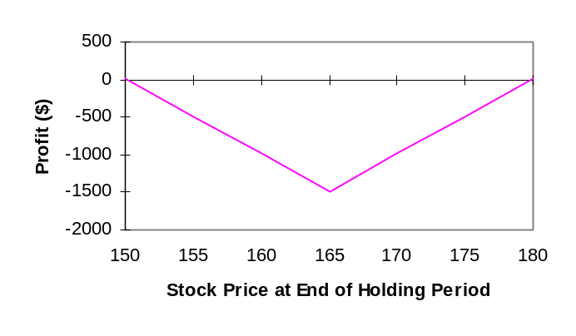

Breakevens:

X + C + P = 165 + 8.10 + 6.75 = 179.85
X – C – P = 165 – 8.10 – 6.75 = 150.15

Minimum profit: –1,485
Maximum profit: ∞

14. (Straddles) X = 165, r_{c} = 0.0571, σ = 0.21, T – t = 26/365 = 0.0712 (based on 26 days between 9/20 and 10/16)

Plugging into the Black-Scholes-Merton model, we obtain the option values on September 20 for stock prices 150, 155, … , 180.

Straddle value on 9/20 = Value of October 165 Call on 9/20 + Value of October 165 Put on 9/20

Π = 100(Straddle Value on 9/20 – 8.10 – 6.75)

Option Value at End of Holding Period
S_{t} October 165 Call October 165 Put Profit
150 0.1911 14.5217 –13.72
155 0.6856 10.0162 –414.82
160 1.8633 6.1939 –679.28
165 4.0250 3.3555 –746.95
170 7.2353 1.5658 –604.89
175 11.2927 0.6233 –293.40
180 15.8803 0.2109 124.12

Note: If you use OptionStrategyAnalyzer10e.xlsm to generate the graphs in this chapter, the horizontal axis will be labeled as the “Stock Price at Expiration.” Here it has been changed to “Stock Price at End of Holding Period.”

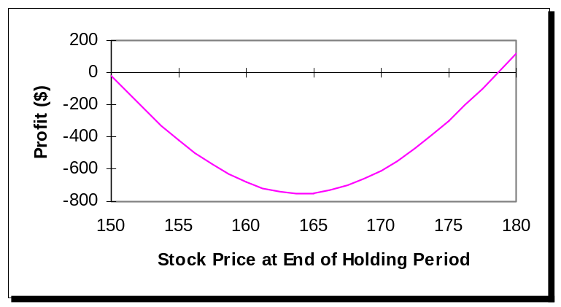

Approximate breakeven stock prices: 178 and 150

15. (Straddles) Buy two October 165 calls at 8.10 each.
Buy one October 165 put at 6.75.

Π = 100{2[Max(0, S_{T} – 165) – 8.10] + Max(0, S_{T} – 165) – 6.75}

Option Values at Expiration
S_{T} October 165 Call October 165 Put Profit
150 0 15 –795
155 0 10 –1,295
160 0 5 –1,795
165 0 0 –2,295
170 5 0 –1,295
175 10 0 –295
180 15 0 705

Note: If you use OptionStrategyAnalyzer10e.xlsm to generate the graphs in this chapter, the horizontal axis will be labeled as the “Stock Price at Expiration.” Here it has been changed to “Stock Price at End of Holding Period.”

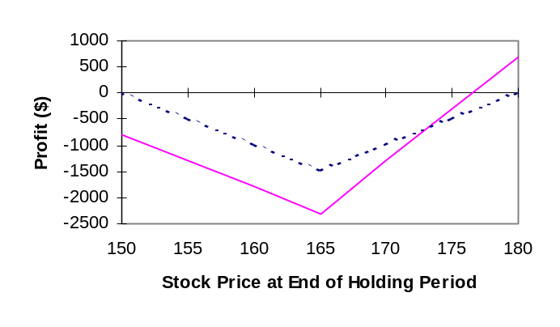

The graph shows the straddle (the dashed line) overlaid with the strap. The strap provides a higher profit on the upside and a larger loss on the downside.

Breakevens:

X + C + P/2 = 165 + 8.10 + 6.75/2 = 176.475
X – P – 2C = 165 – 6.75 – 2(8.10) = 142.05

Minimum profit: –100(2(8.10) + 6.75) = –2,295

16. (Straddles) Sell two August 170 puts at 7.5.
Sell one August 170 call at 3.25.

Π = 100{–2[Max(0, 170 – S_{T}) – 7.5] – Max(0, S_{T} – 170) + 3.25}

Option Value at Expiration
S_{T} August 170 Call August 170 Put Profit
150 0 20 –2,175
155 0 15 –1,175
160 0 10 –175
165 0 5 825
170 0 0 1,825
175 5 0 1,325
180 10 0 825

Note: If you use OptionStrategyAnalyzer10e.xlsm to generate the graphs in this chapter, the horizontal axis will be labeled as the “Stock Price at Expiration.” Here it has been changed to “Stock Price at End of Holding Period.”

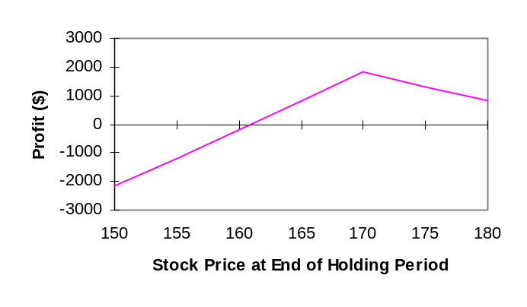

Note that only one breakeven point appears in the graph because of the range of stock prices chosen.

Breakevens:

X + C + 2P = 170 + 3.25 + 2(7.5) = 188.25
X – P – C/2 = 170 – 7.5 – 3.25/2 = 160.875.

Minimum profit:

When S_{T} = 0, Π = C + 2P – 2X = 100[3.25 + 2(7.5) – 2(170)] = –31,175

17. (Box Spreads) Note: If the continuously compounded rate is 0.0535, then the discrete rate is

e^{0.0535} – 1 = 0.055

Buy August 160 call at 8.10.

Sell August 170 call at 3.25.

Buy August 170 put at 7.5.

Sell August 160 put at 2.75.

The net premium is

8.10 – 3.25 + 7.5 – 2.75 = 9.60.

The present value of the future payoff is

(170 – 160)(1.055)^{-0.1260} = 9.933

where 0.1260 is the time to expiration from July 6 to August 21. Thus the net present value is

9.933 – 9.60 = 0.333

This spread is underpriced so buy it. That is, buy the August 160 call and 170 put and sell the August 170 call and 160 put. This will generate a negative cash flow up front of 9.60. At expiration you will receive 10, but the present value of 10 is more than the initial cash flow.

18. (Money Spreads) The following table provides a summary of spread strategies.
Item | Bull Spread  With Calls | Bear Spread  With Puts | Butterfly Spread  With Calls
Value at  expiration | 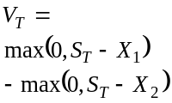 | 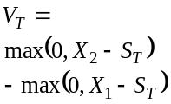 | 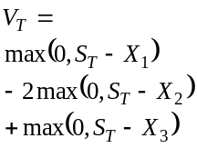
Profit | 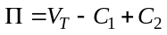 | 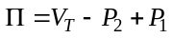 | 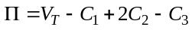
Maximum profit | 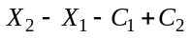 | 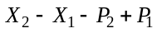 | 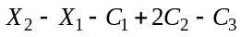
Maximum loss | 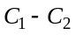 | 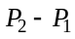 | 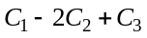
Breakeven | 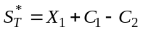 | 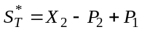 | 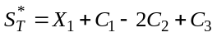  and  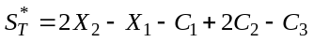

19. (Collars, Straddles) The following table provides a summary of collar and straddle strategies.

Item | Collar Strategies  With Calls and Puts | Straddle  With Calls and Puts
Value at  expiration | 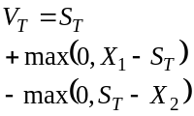 | 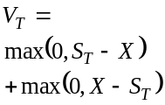
Profit | 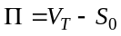 | 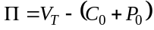
Maximum profit | 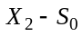 | or unlimited
Maximum loss | 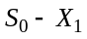 | 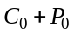
Breakeven | 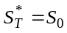 | 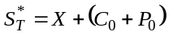  and  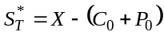

20. (Bull Spreads) The effect of widening the exercise prices is to increase the riskiness of the position as illustrated in the following two graphs.

Narrow exercise prices:
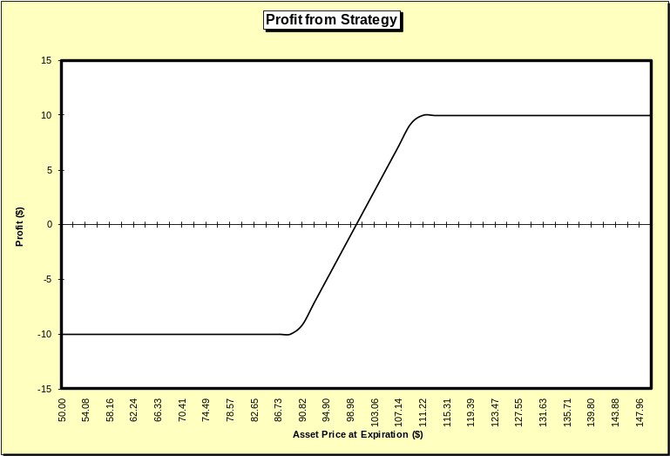

Wide exercise prices:

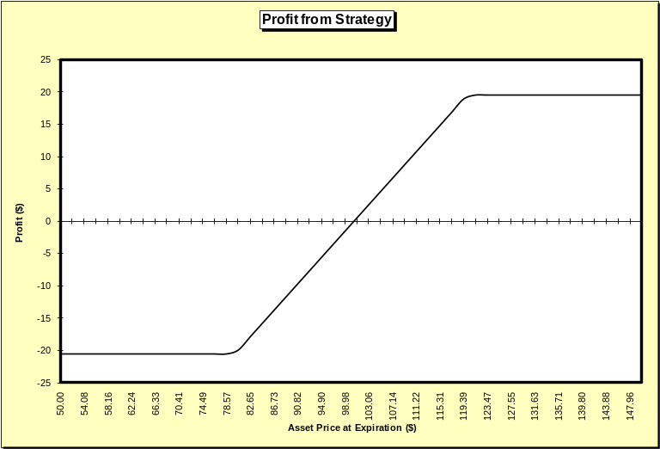

21. (Collars) The effect of widening the exercise prices is to increase the riskiness of the position as illustrated in the following two graphs.

High put exercise price: (note the line does not decline around 95, the graph displays it due to the way the spreadsheet displays the data)

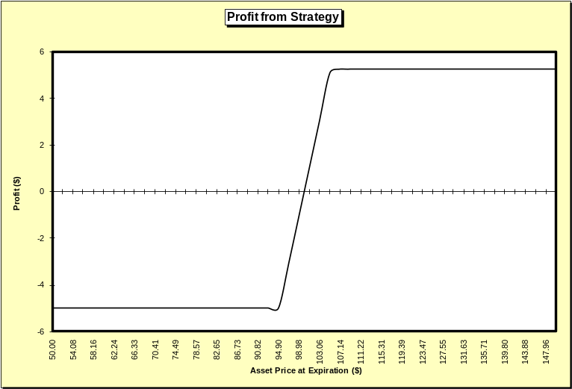

Low put exercise price:

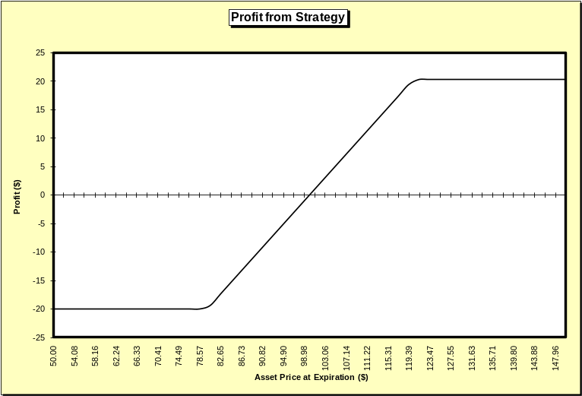

22. (Calendar Spreads) The expectation is for volatility to decline for the first month and then increase in the second month. Hence, one-month options should fall in value and two-month options should rise in value. Thus, if you sell one-month calls and puts (short straddle) and purchase two-month calls and puts (long straddle), this will profit should the volatility expectation come to pass.

23. (Straddles) Buy August 165 put at 4.75.
Buy August 170 call at 3.25.

Π = 100[Max(0, 165 – S_{T}) – 4.75 + Max(0, S_{T} – 170) – 3.25]

Option Value at Expiration
S_{T} August 165 Put August 170 Call Profit
150 15 0 700
155 10 0 200
160 5 0 –300
165 0 0 –800
170 0 0 –800
175 0 5 –300
180 0 10 200

Note: If you use OptionStrategyAnalyzer10e.xlsm to generate the graphs in this chapter, the horizontal axis will be labeled as the “Stock Price at Expiration.” Here it has been changed to “Stock Price at End of Holding Period.”

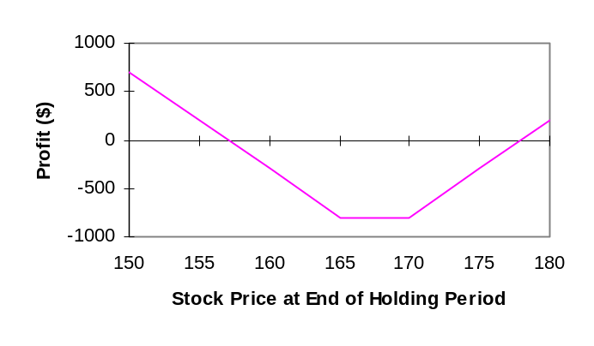

Breakevens:

Π = Max(0, S_{T} – 170) – 3.25 + Max(0, 165 – S_{T}) – 4.75

S_{T} ≤ X
Π = S_{T} – 170 – 3.25 – 4.75

Breakeven = 170 + 3.25 + 4.75 = 178

S_{T} < X
Π = –3.25 + 165 – S_{T} – 4.75

Breakeven = 165 – 4.75 – 3.25 = 157

The strangle is similar to a straddle. By using a lower exercise price put or higher exercise price call, however, the cost is lower though the profit is also lower.

24. (Money, Calendar Spreads) Buy October 165 call at 8.10.
Sell August 170 call at 3.25.

σ = 0.21

On August 1, the October 165 call has T – t = 76/365 = 0.2082 and r_{c} = 0.0571.

On August 1, the August 170 call has T – t = 20/365 = 0.0548 and r_{c} = 0.0535.

Plugging into the Black-Scholes-Merton model, we obtain the option values on August 1 for stock prices of 150, 155, … , 180.

Value of diagonal spread on 8/1 = Value of October 165 call on 8/1 – Value of August 170 Call on 8/1

Profit = 100(Value of spread on 8/1 – 8.10 + 3.25)

Option Price at End of Holding Period
S_{T} October 165 Call August 170 Call Profit
150 1.5867 0.0164 –327.97
155 2.8800 0.1083 –207.83
160 4.7666 0.4793 –56.27
165 7.2909 1.5084 93.25
170 10.4321 3.5836 199.85
175 14.1154 6.8145 245.09
180 18.2350 10.9577 242.73

Note: If you use OptionStrategyAnalyzer10e.xlsm to generate the graphs in this chapter, the horizontal axis will be labeled as the “Stock Price at Expiration.” Here it has been changed to “Stock Price at End of Holding Period.”
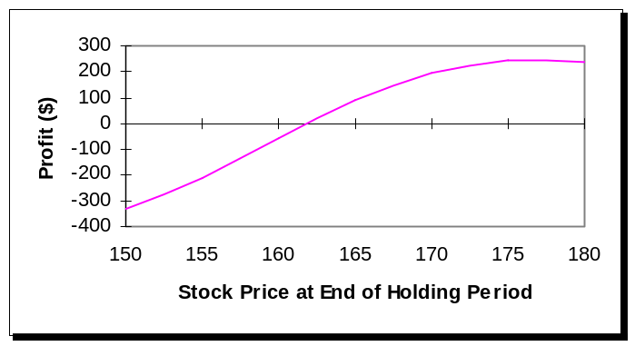
Approximate breakeven stock price: 161.9.

25. (Case) Your instructor will provide the solution for the Second City Options case.

